Deep Learning

Deep Learning is transforming the way machines understand, learn and interact with complex data. Deep learning mimics neural networks of the human brain, it enables computers to autonomously uncover patterns and make informed decisions from vast amounts of unstructured data.

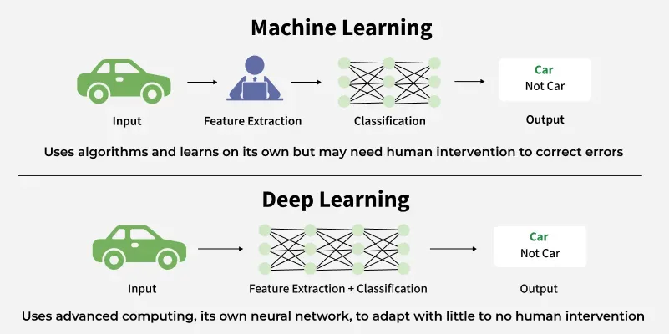

**Neural network**consists of layers of interconnected nodes or neurons that collaborate to process input data. In a **fully connected deep neural network** data flows through multiple layers where each neuron performs nonlinear transformations, allowing the model to learn intricate representations of the data.

In a deep neural network, the **input layer** receives data which passes through **hidden layers** that transform the data using nonlinear functions. The final **output layer** generates the model’s prediction.

Neural networks are machine learning models that mimic the complex functions of the human brain. These models consist of interconnected nodes or neurons that process data, learn patterns, and enable tasks such as pattern recognition and decision-making.

In this article, we will explore the fundamentals of neural networks, their architecture, how they work, and their applications in various fields. Understanding neural networks is essential for anyone interested in the advancements of artificial intelligence.

**Understanding Neural Networks in Deep Learning**

Neural networks are capable of learning and identifying patterns directly from data without pre-defined rules. These networks are built from several key components:

1. **Neurons**: The basic units that receive inputs, each neuron is governed by a threshold and an activation function.
2. **Connections**: Links between neurons that carry information, regulated by weights and biases.
3. **Weights and Biases**: These parameters determine the strength and influence of connections.
4. **Propagation Functions**: Mechanisms that help process and transfer data across layers of neurons.
5. **Learning Rule**: The method that adjusts weights and biases over time to improve accuracy.

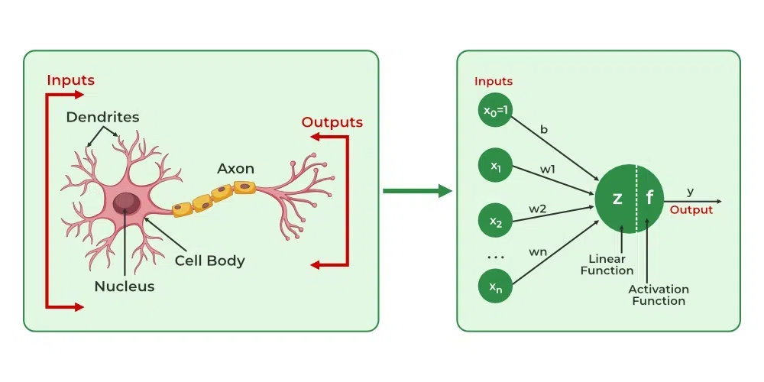

**Learning in neural networks follows a structured, three-stage process:**

1. **Input Computation**: Data is fed into the network.
2. **Output Generation**: Based on the current parameters, the network generates an output.
3. **Iterative Refinement**: The network refines its output by adjusting weights and biases, gradually improving its performance on diverse tasks.

**In an adaptive learning environment:**

* The neural network is exposed to a simulated scenario or dataset.
* Parameters such as weights and biases are updated in response to new data or conditions.
* With each adjustment, the network’s response evolves, allowing it to adapt effectively to different tasks or environments.

**Layers in Neural Network Architecture**

1. **Input Layer:** This is where the network receives its input data. Each input neuron in the layer corresponds to a feature in the input data.
2. **Hidden Layers:** These layers perform most of the computational heavy lifting. A neural network can have one or multiple hidden layers. Each layer consists of units (neurons) that transform the inputs into something that the output layer can use.
3. **Output Layer:** The final layer produces the output of the model. The format of these outputs varies depending on the specific task (e.g., classification, regression).

Backpropagation

After forward propagation, the network evaluates its performance using a loss function, which measures the difference between the actual output and the predicted output. The goal of training is to minimize this loss. This is where backpropagation comes into play:

Loss Calculation: The network calculates the loss, which provides a measure of error in the predictions. The loss function could vary; common choices are mean squared error for regression tasks or cross-entropy loss for classification.

Gradient Calculation: The network computes the gradients of the loss function with respect to each weight and bias in the network. This involves applying the chain rule of calculus to find out how much each part of the output error can be attributed to each weight and bias.

Weight Update: Once the gradients are calculated, the weights and biases are updated using an optimization algorithm like stochastic gradient descent (SGD). The weights are adjusted in the opposite direction of the gradient to minimize the loss. The size of the step taken in each update is determined by the learning rate.

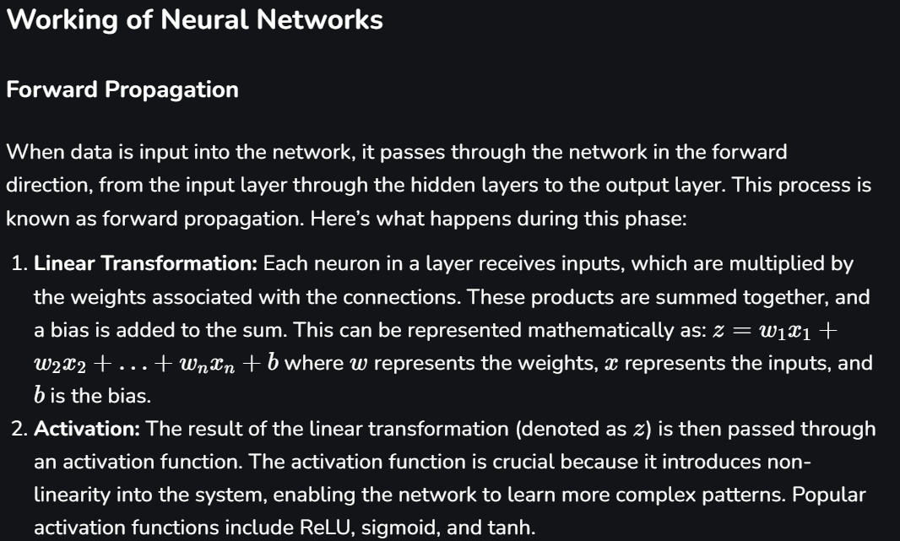

| **Machine Learning** | **Deep Learning** |
| --- | --- |
| Apply statistical algorithms to learn the hidden patterns and relationships in the dataset. | Uses artificial neural network architecture to learn the hidden patterns and relationships in the dataset. |
| Can work on the smaller amount of dataset | Requires the larger volume of dataset compared to machine learning |
| Better for the low-label task. | Better for complex task like image processing, natural language processing, etc. |
| Takes less time to train the model. | Takes more time to train the model. |
| A model is created by relevant features which are manually extracted from images to detect an object in the image. | Relevant features are automatically extracted from images. It is an end-to-end learning process. |
| Less complex and easy to interpret the result. | More complex, it works like the black box interpretations of the result are not easy. |
| It can work on the CPU or requires less computing power as compared to deep learning. | It requires a high-performance computer with GPU. |

**Types of neural networks**

1. [**Feedforward neural networks (FNNs)**](https://www.geeksforgeeks.org/feedforward-neural-network/) are the simplest type of ANN, where data flows in one direction from input to output. It is used for basic tasks like classification.
2. [**Convolutional Neural Networks (CNNs)**](https://www.geeksforgeeks.org/introduction-convolution-neural-network/) are specialized for processing grid-like data, such as images. CNNs use convolutional layers to detect spatial hierarchies, making them ideal for computer vision tasks.
3. [**Recurrent Neural Networks (RNNs)**](https://www.geeksforgeeks.org/introduction-to-recurrent-neural-network/)are able to process sequential data, such as time series and natural language. RNNs have loops to retain information over time, enabling applications like language modelling and speech recognition. Variants like LSTMs and GRUs address vanishing gradient issues.
4. [**Generative Adversarial Networks (GANs)**](https://www.geeksforgeeks.org/generative-adversarial-network-gan/) consist of two networks—a generator and a discriminator—that compete to create realistic data. GANs are widely used for image generation, style transfer and data augmentation.
5. [**Autoencoders**](https://www.geeksforgeeks.org/auto-encoders/) are unsupervised networks that learn efficient data encodings. They compress input data into a latent representation and reconstruct it, useful for dimensionality reduction and anomaly detection.
6. [**Transformer Networks**](https://www.geeksforgeeks.org/getting-started-with-transformers/) has revolutionized NLP with self-attention mechanisms. Transformers excel at tasks like translation, text generation and sentiment analysis, powering models like GPT and BERT.

**Deep Learning Applications**

**1. Computer vision**

In computer vision, deep learning models enable machines to identify and understand visual data. Some of the main applications of deep learning in computer vision include:

* [**Object detection and recognition**](https://www.geeksforgeeks.org/what-is-object-detection-in-computer-vision/)**:**Deep learning models are used to identify and locate objects within images and videos, making it possible for machines to perform tasks such as self-driving cars, surveillance and robotics.
* [**Image classification**](https://www.geeksforgeeks.org/what-is-image-classification/)**:**Deep learning models can be used to classify images into categories such as animals, plants and buildings. This is used in applications such as medical imaging, quality control and image retrieval.
* [**Image segmentation**](https://www.geeksforgeeks.org/explain-image-segmentation-techniques-and-applications/)**:**Deep learning models can be used for image segmentation into different regions, making it possible to identify specific features within images.

**2. Natural language processing (NLP)**

In NLP, deep learning model enables machines to understand and generate human language. Some of the main applications of deep learning in NLP include:

* **Automatic Text Generation:** Deep learning model can learn the corpus of text and new text like summaries; essays can be automatically generated using these trained models.
* [**Language translation**](https://www.geeksforgeeks.org/machine-translation-of-languages-in-artificial-intelligence/)**:** Deep learning models can translate text from one language to another, making it possible to communicate with people from different linguistic backgrounds.
* [**Sentiment analysis**](https://www.geeksforgeeks.org/what-is-sentiment-analysis/)**:**Deep learning models can analyse the sentiment of a piece of text, making it possible to determine whether the text is positive, negative or neutral.
* **Speech recognition:** Deep learning models can recognize and transcribe spoken words, making it possible to perform tasks such as speech-to-text conversion, voice search and voice-controlled devices.

**3. Reinforcement learning**

In reinforcement learning, deep learning works as training agents to take action in an environment to maximize a reward. Some of the main applications of deep learning in reinforcement learning include:

* [**Game playing**](https://www.geeksforgeeks.org/game-playing-in-artificial-intelligence/)**:**Deep reinforcement learning models have been able to beat human experts at games such as Go, Chess and Atari.
* [**Robotics**](https://www.geeksforgeeks.org/robotics-introduction/)**:**Deep reinforcement learning models can be used to train robots to perform complex tasks such as grasping objects, navigation and manipulation.
* [**Control systems**](https://www.geeksforgeeks.org/control-system/)**:**Deep reinforcement learning models can be used to control complex systems such as power grids, traffic management and supply chain optimization.

**Artificial Neural Networks**

Artificial Neural Networks contain artificial neurons, which are called units. These units are arranged in a series of layers that together constitute the whole Artificial Neural Network in a system. A layer can have only a dozen units or millions of units, as this depends on how the complex neural networks will be required to learn the hidden patterns in the dataset. Commonly, an Artificial Neural Network has an input layer, an output layer, as well as hidden layers. The input layer receives data from the outside world, which the neural network needs to analyse or learn about. Then, this data passes through one or multiple hidden layers that transform the input into data that is valuable for the output layer. Finally, the output layer provides an output in the form of a response of the Artificial Neural Networks to the input data provided.

In the majority of neural networks, units are interconnected from one layer to another. Each of these connections has weights that determine the influence of one unit on another unit. As the data transfers from one unit to another, the neural network learns more and more about the data, which eventually results in an output from the output layer.

**Artificial neurons vs biological neurons**

The concept of artificial neural networks comes from biological neurons found in animal brains So they share a lot of similarities in structure and function wise.

* **Structure**: The**structure of artificial neural networks**is inspired by biological neurons. A biological neuron has a cell body or soma to process the impulses, dendrites to receive them, and an axon that transfers them to other neurons. The input nodes of artificial neural networks receive input signals, the hidden layer nodes compute these input signals, and the output layer nodes compute the final output by processing the hidden layer's results using activation functions.

| **Biological Neuron** | **Artificial Neuron** |
| --- | --- |
| Dendrite | Inputs |
| Cell nucleus or Soma | Nodes |
| Synapses | Weights |
| Axon | Output |

* **Synapses**: [**Synapses**](https://www.geeksforgeeks.org/synapse/) are the links between biological neurons that enable the transmission of impulses from dendrites to the cell body. Synapses are the weights that join the one-layer nodes to the next-layer nodes in artificial neurons. The strength of the links is determined by the weight value.
* **Learning**: In biological neurons, learning happens in the cell body nucleus or soma, which has a nucleus that helps to process the impulses. An action potential is produced and travels through the axons if the impulses are powerful enough to reach the threshold. This becomes possible by synaptic plasticity, which represents the ability of synapses to become stronger or weaker over time in reaction to changes in their activity. In artificial neural networks, backpropagation is a technique used for learning, which adjusts the weights between nodes according to the error or differences between predicted and actual outcomes.

| **Biological Neuron** | **Artificial Neuron** |
| --- | --- |
| Synaptic plasticity | Backpropagations |

* **Activation**: In biological neurons, activation is the firing rate of the neuron which happens when the impulses are strong enough to reach the threshold. In artificial neural networks, A mathematical function known as an activation function maps the input to the output, and executes activations.

**Convolutional Neural Network (CNN):**

**Convolutional Neural Network (CNN)** is an advanced version of [**artificial neural networks (ANNs)**](https://www.geeksforgeeks.org/artificial-neural-networks-and-its-applications/), primarily designed to extract features from grid-like matrix datasets. This is particularly useful for visual datasets such as images or videos, where data patterns play a crucial role. CNNs are widely used in [**computer vision**](https://www.geeksforgeeks.org/computer-vision-introduction/) applications due to their effectiveness in processing visual data.

CNNs consist of multiple layers like the input layer, Convolutional layer, pooling layer, and fully connected layers. Let's learn more about CNNs in detail.

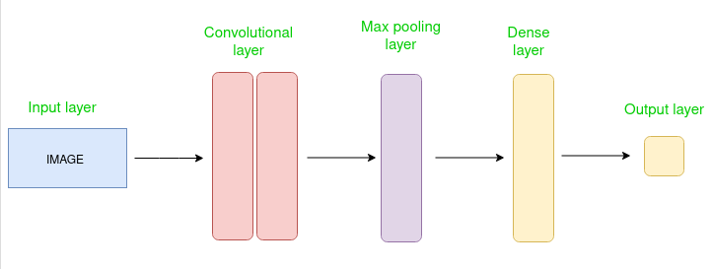

**Layers Used to Build ConvNets**

A complete Convolution Neural Networks architecture is also known as covnets. A covnets is a sequence of layers, and every layer transforms one volume to another through a differentiable function.

Let’s take an example by running a covnets on of image of dimension 32 x 32 x 3.

* **Input Layers:** It’s the layer in which we give input to our model. In CNN, Generally, the input will be an image or a sequence of images. This layer holds the raw input of the image with width 32, height 32, and depth 3.
* [**Convolutional Layers**](https://www.geeksforgeeks.org/what-are-convolution-layers/)**:**This is the layer, which is used to extract the feature from the input dataset. It applies a set of learnable filters known as the kernels to the input images. The filters/kernels are smaller matrices usually 2x2, 3x3, or 5x5 shape. it slides over the input image data and computes the dot product between kernel weight and the corresponding input image patch. The output of this layer is referred as feature maps. Suppose we use a total of 12 filters for this layer we’ll get an output volume of dimension 32 x 32 x 12.
* [**Activation Layer**](https://www.geeksforgeeks.org/activation-functions-neural-networks/): By adding an activation function to the output of the preceding layer, activation layers add nonlinearity to the network. it will apply an element-wise activation function to the output of the convolution layer. Some common activation functions are **RELU**: max(0, x),  **Tanh**, **Leaky RELU**, etc. The volume remains unchanged hence output volume will have dimensions 32 x 32 x 12.
* [**Pooling layer**](https://www.geeksforgeeks.org/cnn-introduction-to-pooling-layer/): This layer is periodically inserted in the covnets and its main function is to reduce the size of volume which makes the computation fast reduces memory and also prevents overfitting. Two common types of pooling layers are **max pooling** and **average pooling**. If we use a max pool with 2 x 2 filters and stride 2, the resultant volume will be of dimension 16x16x12.

**Advantages of CNNs**

1. Good at detecting patterns and features in images, videos, and audio signals.
2. Robust to translation, rotation, and scaling invariance.
3. End-to-end training, no need for manual feature extraction.
4. Can handle large amounts of data and achieve high accuracy.

**Disadvantages of CNNs**

1. Computationally expensive to train and require a lot of memory.
2. Can be prone to overfitting if not enough data or proper regularization is used.
3. Requires large amounts of labelled data.
4. Interpretability is limited, it's hard to understand what the network has learned.

**Recurrent Neural Network:**

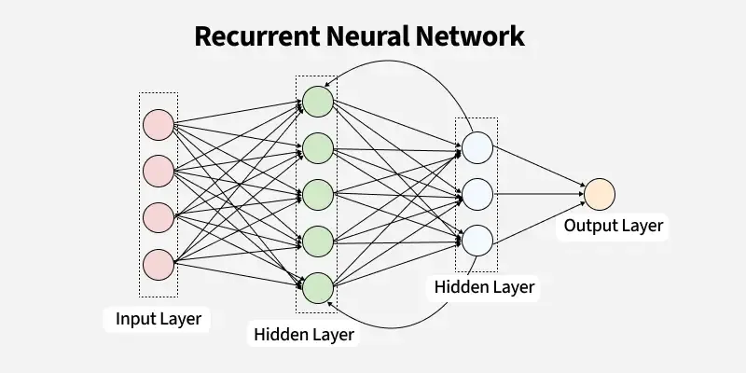

**1. Recurrent Neurons**

The fundamental processing unit in RNN is a Recurrent Unit. They hold a hidden state that maintains information about previous inputs in a sequence. Recurrent units can "remember" information from prior steps by feeding back their hidden state, allowing them to capture dependencies across time.

**2. RNN Unfolding**

RNN unfolding or unrolling is the process of expanding the recurrent structure over time steps. During unfolding each step of the sequence is represented as a separate layer in a series illustrating how information flows across each time step.

This unrolling enables [backpropagation through time (BPTT)](https://www.geeksforgeeks.org/ml-back-propagation-through-time/) a learning process where errors are propagated across time steps to adjust the network’s weights enhancing the RNN’s ability to learn dependencies within sequential data.

**How does RNN work?**

At each time step RNNs process units with a fixed activation function. These units have an internal hidden state that acts as memory that retains information from previous time steps. This memory allows the network to store past knowledge and adapt based on new inputs.

**Variants of Recurrent Neural Networks (RNNs)**

**There are several variations of RNNs, each designed to address specific challenges or optimize for certain tasks:**

**1. Vanilla RNN**

This simplest form of RNN consists of a single hidden layer where weights are shared across time steps. Vanilla RNNs are suitable for learning short-term dependencies but are limited by the vanishing gradient problem, which hampers long-sequence learning.

**2. Bidirectional RNNs**

[Bidirectional RNNs](https://www.geeksforgeeks.org/bidirectional-recurrent-neural-network/) process inputs in both forward and backward directions, capturing both past and future context for each time step. This architecture is ideal for tasks where the entire sequence is available, such as named entity recognition and question answering.

**3. Long Short-Term Memory Networks (LSTMs)**

[Long Short-Term Memory Networks (LSTMs)](https://www.geeksforgeeks.org/deep-learning-introduction-to-long-short-term-memory/) introduce a memory mechanism to overcome the vanishing gradient problem. Each LSTM cell has three gates:

* Input Gate: Controls how much new information should be added to the cell state.
* Forget Gate: Decides what past information should be discarded.
* Output Gate: Regulates what information should be output at the current step. This selective memory enables LSTMs to handle long-term dependencies, making them ideal for tasks where earlier context is critical.

**4. Gated Recurrent Units (GRUs)**

[Gated Recurrent Units (GRUs)](https://www.geeksforgeeks.org/gated-recurrent-unit-networks/)simplify LSTMs by combining the input and forget gates into a single update gate and streamlining the output mechanism. This design is computationally efficient, often performing similarly to LSTMs and is useful in tasks where simplicity and faster training are beneficial.

AI MCQ:

**1. Which of the following architecture is also known as systolic arrays?**

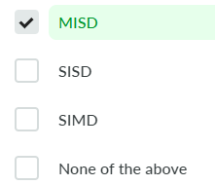

**Answer**

MISD architecture is also known as systolic arrays.

**2. The correct ways to solve a problem of state-space search are?**

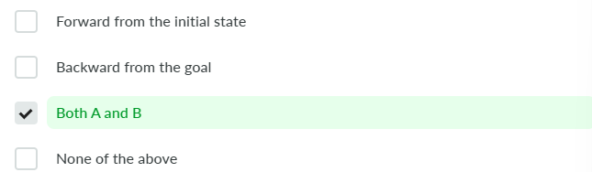

**Answer**

The only 2 ways to solve a problem of state-space search problem are given in options (A) and (B).

**3. The different types of machine learning are?**



**Answer**

The 3 types of machine learning are: Supervised, Unsupervised, and Reinforcement Learning.

**4. The measure of performance of an AI agent is measured using?**

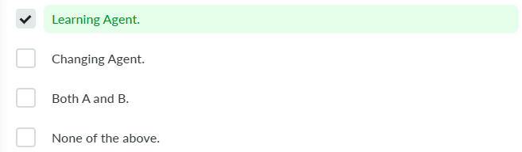

**Answer**

The performance of an AI agent is improved using the learning agent.

**5. The name of the Artificial Intelligence system developed by Daniel Bobrow was?**

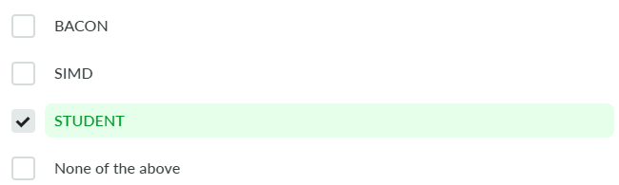

**Answer**

The name of the Artificial Intelligence system developed by Daniel Bobrow was STUDENT developed in the Lisp Language in 1964.

**6. The process of breaking an image into parts is called?**

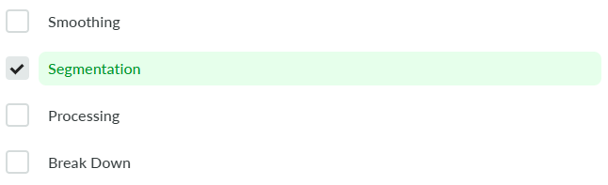

**Answer**

Segmentation is the process of breaking an image into groups based on the similarity of pixels.

**7. The process of making 2 logical expressions look identical is called?**

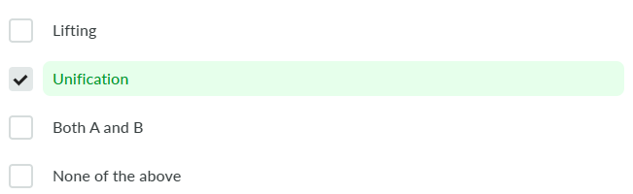

**Answer**

Unification is the process of making 2 logical expressions look identical.

**8. The proposition symbols in AI are?**

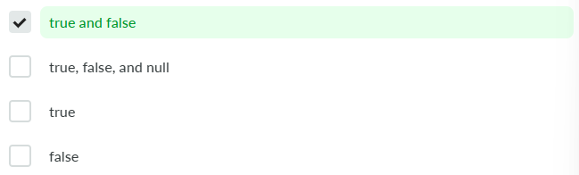

**9. The things considered in the design of a learning element are?**



**Answer**

The 3 main things to be considered in the design of a learning element are: Components, Feedback, and Representation.

**10. What are different machine learning methods?**



**Answer**

The machine learning methods include Memorization, Analogy, and Deduction.

**11. What are the different types of Artificial Intelligence approaches?**

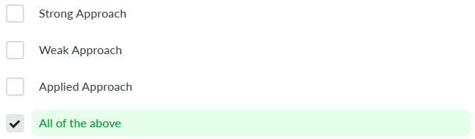

**Answer**

All the given options are different types of AI approaches used in different scenarios.

**12. What is meant by a “Complete Algorithm”?**

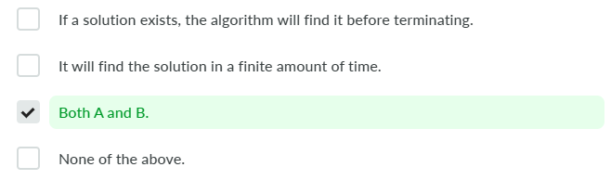

**Answer**

A complete algorithm is an algorithm that finds a solution to a problem (if it exists) in finite time.

**13. What is state space in AI?**

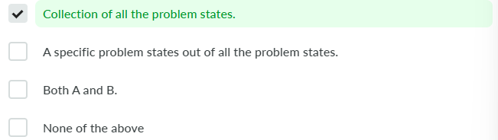

**Answer**

State Space in AI is defined as the collection of all the problem states.

**14. What is the work of Task Environment and Rational Agents?**

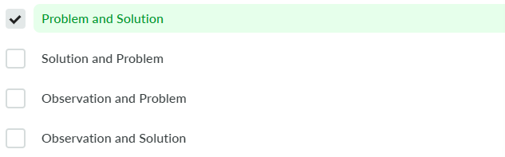

**Answer**

Task Environments provides an issue and Rational Agents provides the corresponding solution.

**15. Procedural Domain Knowledge in a rule-based system, is in the form of?**

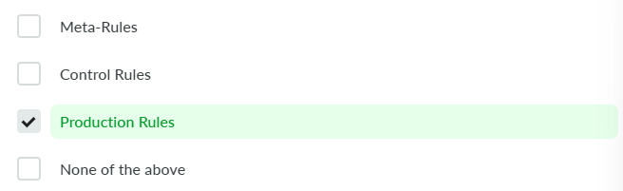

**Answer**

Procedural Domain Knowledge in a rule-based system, is in the form of Production Rules.

**16. Which of the following are appropriate levels for a knowledge-based AI agent?**

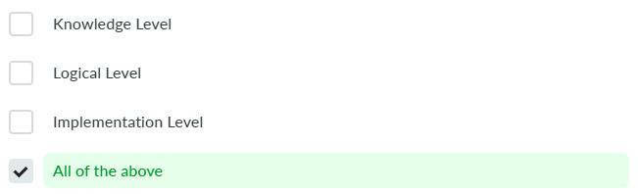

**Answer**

The 3 main levels for a knowledge-based AI agent are: Knowledge, Logical, and Implementation level.

**17. Which of the following are heuristic search algorithms?**



**18. Which of the following are informed search methods?**



**19. Which of the following are valid 3D image processing techniques?**



**20. Which of the following are valid Machine Learning algorithms?**

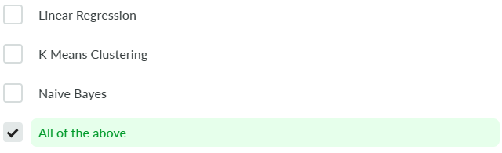

**21. Which of the following is a type of artificial intelligence agent?**

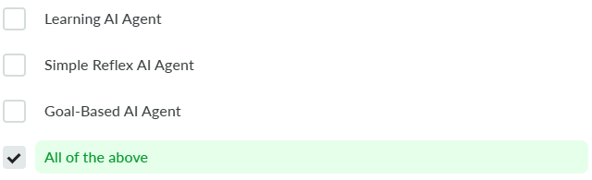

**Answer**

There are a total of 5 AI agents: Simple Reflex Agent, Model-Based Reflex Agent, Goal-based reflex agent, utility-based agent, learning agent.

**22. Which of the following is not a type of AI?**

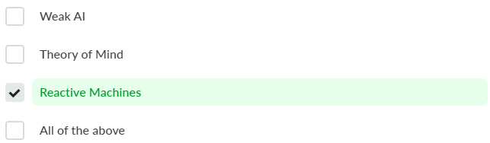

**Answer**

Reactive Machines are not a type of AI based on functionality.

**23. Which of the following is not an application of artificial intelligence?**



**Answer**

Other than Database Management System, all the other options are viable fields of study in Artificial Intelligence.

**24. Which of the following is the common language for Artificial Intelligence?**



**Answer**

While programming can be done in any language, in today’s world Python has become the go-to language for AI and ML-related tasks due to its vast and diverse library functionalities.

**25. Which of the following search method takes less memory space?**

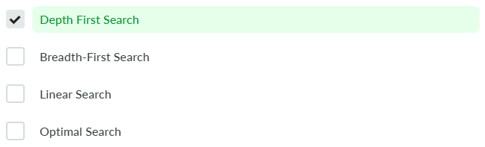

**Answer**

Depth First Search takes the least memory consumption because only the nodes on the current path are stored.

**26. Which of the following symbols in AI are logical symbols?**

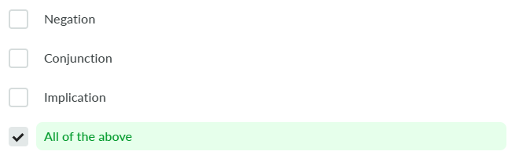

**Answer**

The logical symbols in AI are: Negation, Conjunction, Disjunction, Implication, and Biconditional symbols.

**27. ‘The Imitation Game’ was the original name of?**

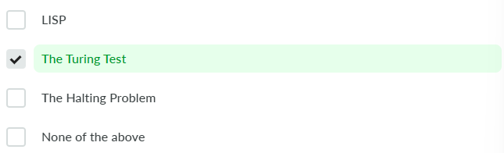

**Answer**

The Turing Test was originally called the ‘The Imitation Game’ by its creator.

**28. How is the brightness of a pixel on the screen increased?**

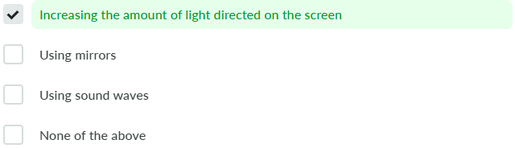

**Answer**

The brightness of a pixel is directly proportional to the amount of light incident on the screen.

**29. A hybrid Bayesian Network consists of?**

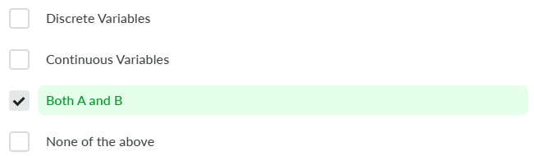

**Answer**

Discrete and Continuous variables both act as numerical inputs to a hybrid Bayesian network.

**30. AI agents are composed of?**



**Answer**

AI agents implement mapping for perceptions to actions.

**31. Artificial Intelligence is associated with computers of which generation?**



**Answer**

Fifth Generation computers are said to be able to have Artificial Intelligence within them.

**32. Blind Search can be used for which of the following situations?**

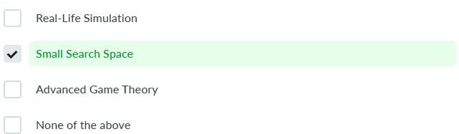

**Answer**

Blind Search doesn’t contain any domain information such as closeness and hence it is best used for a Small Search Space.

**33. Components of an expert system are?**

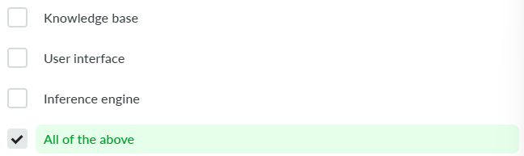

**34. Decisions of Victory/Defeat are made in Game trees using which algorithm?**

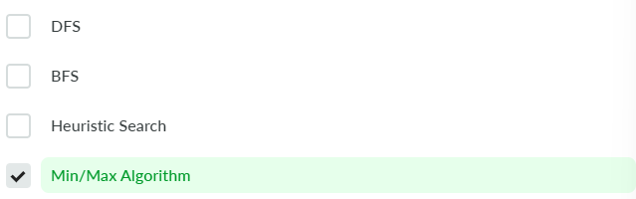

**Answer**

The Min/Max algorithm is preferred over other search-based algorithms in Game trees to make win/loss decisions optimally.

**35. Exploratory Learning is another name for?**

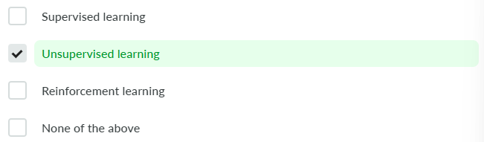

**Answer**

In unsupervised learning, no external supervision is required so the machine learns on the basis of exploring the datasets themselves.

**36. For external action selection, which element is used in the agent?**

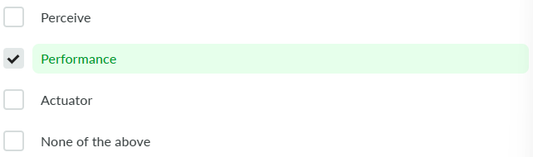

**37. How can we achieve Artificial Intelligence in real life?**

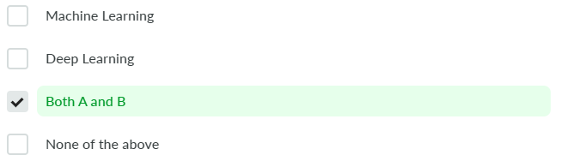

**38. How do we multiply 2 numbers in LISP?**

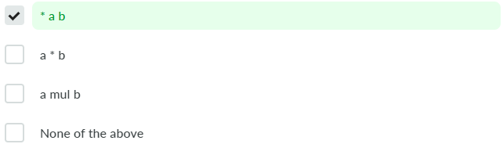

**39. How does an AI agent interact with its environment?**

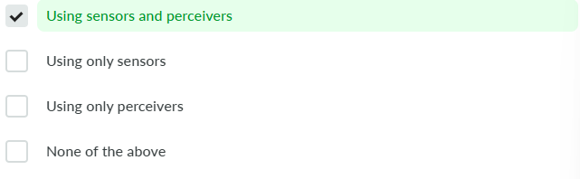

**Answer**

An AI agent perceives and acts upon the environment using Sensors and Actuators. With Sensors, it senses the surrounding, and with Actuators, it acts on it.

**40. How is a decision reached upon by a decision tree?**

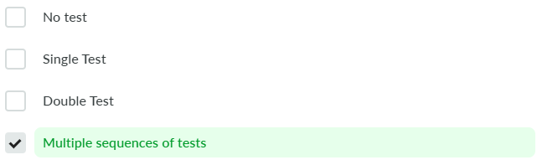

**41. The “Father of Artificial Intelligence” is:**



**42. How many types of observing environments are there?**

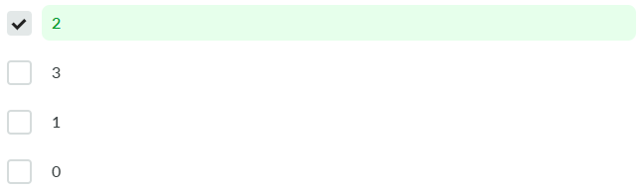

**Answer**

There are 2 types of observing environments: Fully and Partial.

**43. How many types of quantification are there in AI?**

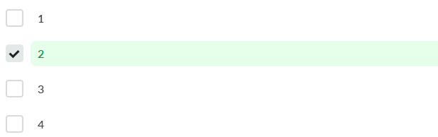

**Answer**

There are 2 types of quantification in AI: Universal and Existential.

**44. How many types of recognition are there in AI?**

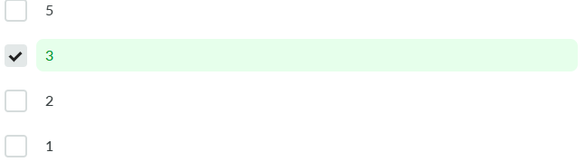

**Answer**

There are 3 types of recognition in AI: Biometric Identification, Content-Based Image Retrieval, Handwriting Recognition.

**45. If a machine can change its course of action based on the external environment on its own, the machine is called?**

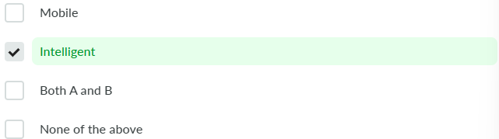

**Answer**

Machines that can change their course of action by making their own decisions are said to be Intelligent.

**46. In how many category processes is Artificial Intelligence classified in?**

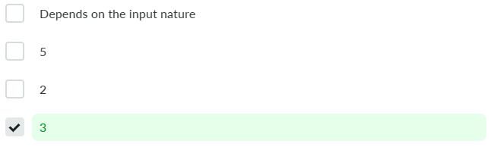

**Answer**

AI is classified into 3 categories processes: Sensing, Reasoning, and Acting.

**47. Inference engines work on the principle of?**

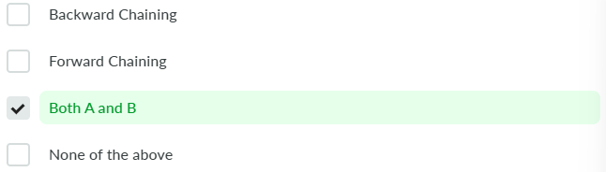

**Answer**

The modes on which inference engines work are forward and backward chaining.

**Machines that try to imitate human intuition while handling vague information lie in the field of AI called?**

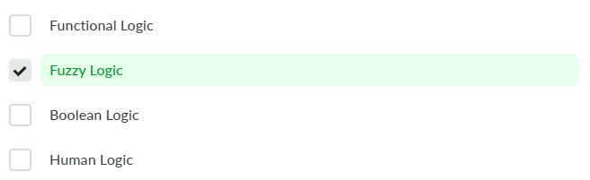

**Answer**

Fuzzy Logic allows machines to mimic human intuition when provided with information that is vague in nature.

**DFS uses the lesser amount of memory because at a time the path from the node to a root is only stored in the memory stack unlike BFS which will have to store the whole tree within it.**

**Parsing is used for?**

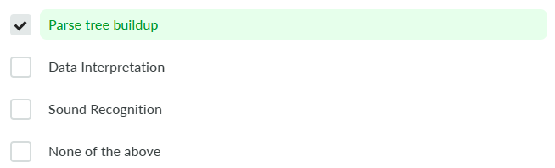

**Answer**

The process of building up a parse tree for an input string is called parsing. **PEAS is an abbreviation for?**

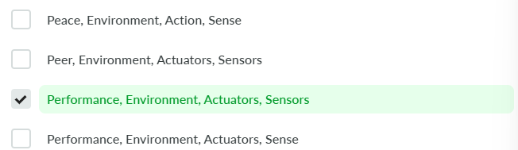

**Answer**

PEAS is an abbreviation for Performance, Environment, Actuators, Sensors.

